WEEK – 4 (MANDATORY)

SPRING REST HANDSON
Hands on 1
Create a Spring Web Project using Maven
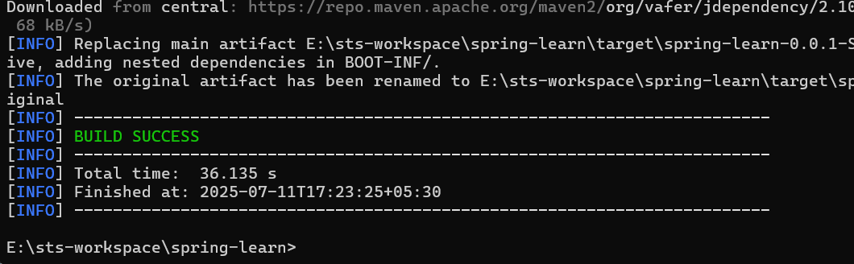
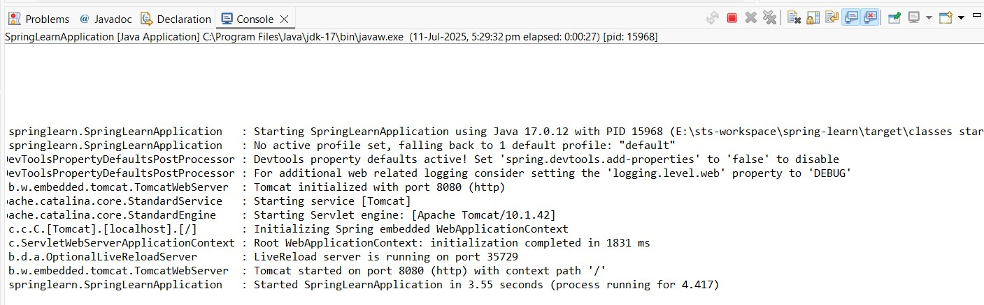
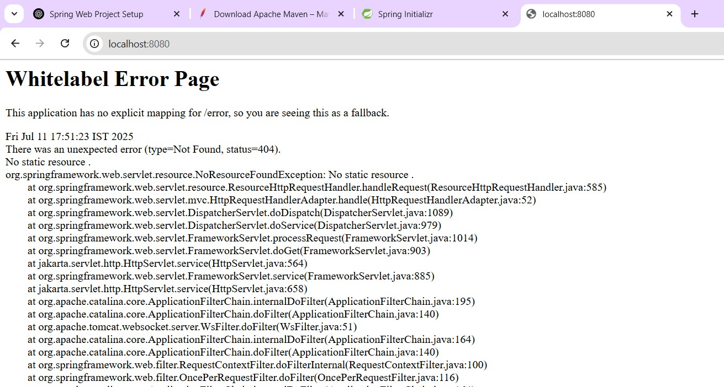

Hands on 4
Spring Core – Load Country from Spring Configuration XML
File name: Country.java
package com.cognizant.springlearn;
import org.slf4j.Logger;
import org.slf4j.LoggerFactory;
public class Country {
private static final Logger LOGGER = LoggerFactory.getLogger(Country.class);
private String code; private String name;
public Country() {
LOGGER.debug("Inside Country Constructor.");
}
public String getCode() { LOGGER.debug("Getting country code."); return code;
}
public void setCode(String code) { LOGGER.debug("Setting country code."); this.code = code;
}
public String getName() { LOGGER.debug("Getting country name."); return name;
}
public void setName(String name) { LOGGER.debug("Setting country name."); this.name = name;
}
@Override
public String toString() {
return "Country [code=" + code + ", name=" + name + "]";
}
}
File name: country.xml
<?xml version="1.0" encoding="UTF-8"?>
<beans xmlns="http://www.springframework.org/schema/beans" xmlns:xsi="http://www.w3.org/2001/XMLSchema-instance" xsi:schemaLocation="
http://www.springframework.org/schema/beans http://www.springframework.org/schema/beans/spring-beans.xsd">
<bean id="country" class="com.cognizant.springlearn.Country">
<property name="code" value="IN" />
<property name="name" value="India" />
</bean>
</beans>
File name: Pom.xml
<project xmlns="http://maven.apache.org/POM/4.0.0" xmlns:xsi="http://www.w3.org/2001/XMLSchema-instance" xsi:schemaLocation="
http://maven.apache.org/POM/4.0.0 http://maven.apache.org/xsd/maven-4.0.0.xsd">
<modelVersion>4.0.0</modelVersion>
<groupId>com.cognizant</groupId>
<artifactId>spring-learn</artifactId>
<version>0.0.1-SNAPSHOT</version>
<packaging>jar</packaging>
<name>spring-learn</name>
<properties>
<maven.compiler.source>17</maven.compiler.source>
<maven.compiler.target>17</maven.compiler.target>
<project.build.sourceEncoding>UTF-8</project.build.sourceEncoding>
</properties>
<dependencies>
<!-- Spring Core and Context -->
<dependency>
<groupId>org.springframework</groupId>
<artifactId>spring-context</artifactId>
<version>5.3.30</version>
</dependency>
<!-- SLF4J API for logging -->
<dependency>
<groupId>org.slf4j</groupId>
<artifactId>slf4j-api</artifactId>
<version>1.7.36</version>
</dependency>
<!-- Logback Classic for SLF4J implementation -->
<dependency>
<groupId>ch.qos.logback</groupId>
<artifactId>logback-classic</artifactId>
<version>1.2.11</version>
</dependency>
</dependencies>

</project>

File name: SpringLearnApplication.java
Packagecom.cognizant.springlearn; import org.slf4j.Logger;
import org.slf4j.LoggerFactory;
import org.springframework.context.ApplicationContext;
import org.springframework.context.support.ClassPathXmlApplicationContext;
public class SpringLearnApplication {
private static final Logger LOGGER = LoggerFactory.getLogger(SpringLearnApplication.class);
public static void main(String[] args) { LOGGER.debug("START of main"); displayCountry(); LOGGER.debug("END of main");
}
public static void displayCountry() {
ApplicationContext context = new ClassPathXmlApplicationContext("country.xml");

Country country = context.getBean("country", Country.class);
LOGGER.debug("Country : {}", country.toString());
}
}

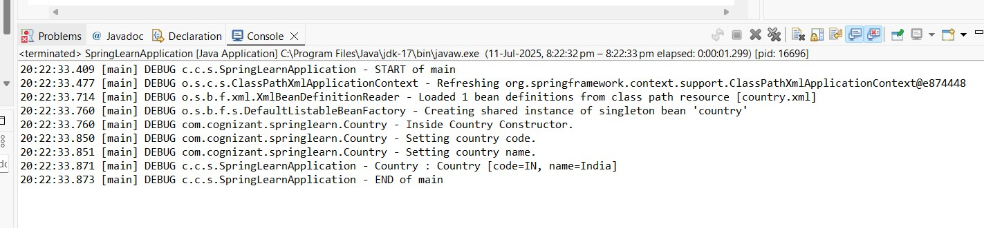
OUTPUT
<bean> Tag
Defines a bean (object) in the Spring container.
<bean id="country" class="com.cognizant.springlearn.Country">

- id -- unique name for the bean in Spring
- class -- full-qualified class name to be instantiated

<property> Tag
Used to set values of the bean's fields via setter methods.
<property name="code" value="IN" />
- name matches the setter method name setCode()
- value is the string value passed

ApplicationContext
Interface that represents the Spring IoC (Inversion of Control) container. It is responsible for:
- Loading bean definitions
- Instantiating and wiring beans
- Managing bean life cycle

ClassPathXmlApplicationContext
Implementation of ApplicationContext that loads context from an XML file located in the classpath. ApplicationContext context = new ClassPathXmlApplicationContext("country.xml");
This line tells Spring to:
- Look for country.xml in the classpath
- Parse it
- Instantiate all <bean>s defined in it

context.getBean("country", Country.class)
This retrieves the bean named "country" of type Country. Internally:
- Spring looks for a bean with id="country"
- Uses reflection to instantiate the class com.cognizant.springlearn.Country
- Calls its constructor
- Invokes setter methods (setCode, setName) with values from XML
- Returns the fully initialized Country object

SPRING REST HANDSON
Hello World RESTful Web Service File name: HelloController.java
package com.cognizant.springlearn.controller; import org.slf4j.Logger;
import org.slf4j.LoggerFactory;
import org.springframework.web.bind.annotation.GetMapping; import org.springframework.web.bind.annotation.RestController; @RestController
public class HelloController {
private static final Logger LOGGER = LoggerFactory.getLogger(HelloController.class); @GetMapping("/hello")
public String sayHello() {
LOGGER.info("START");
String response = "Hello World!!";
LOGGER.info("END");
return response;
}
}
File name: SpringLearnApplication.java package com.cognizant.springlearn; import org.slf4j.Logger;
import org.slf4j.LoggerFactory;
import org.springframework.boot.SpringApplication;
import org.springframework.boot.autoconfigure.SpringBootApplication; @SpringBootApplication
public class SpringLearnApplication {
private static final Logger LOGGER = LoggerFactory.getLogger(SpringLearnApplication.class); public static void main(String[] args) {
LOGGER.debug("START of main"); SpringApplication.run(SpringLearnApplication.class, args); LOGGER.debug("END of main");
}
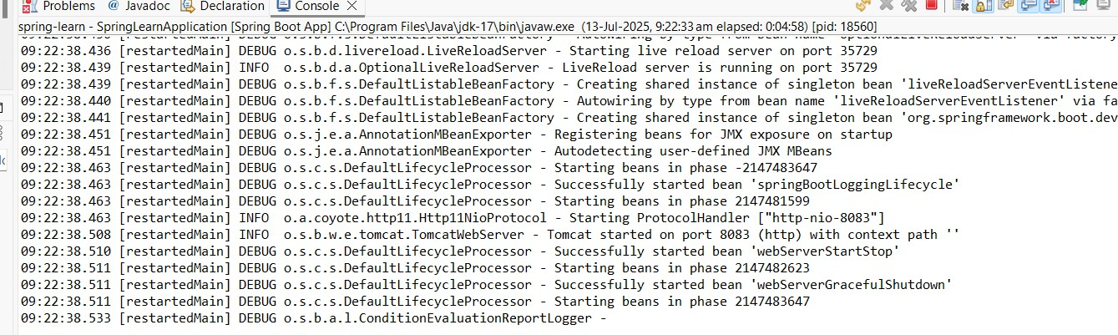
}

Output:
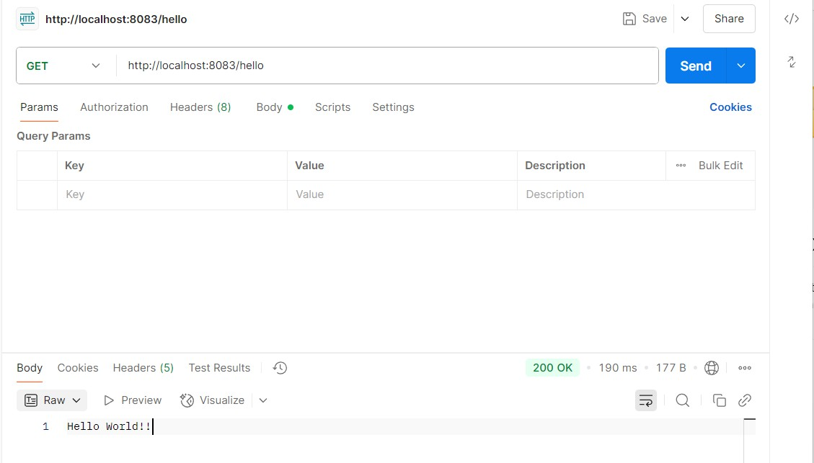

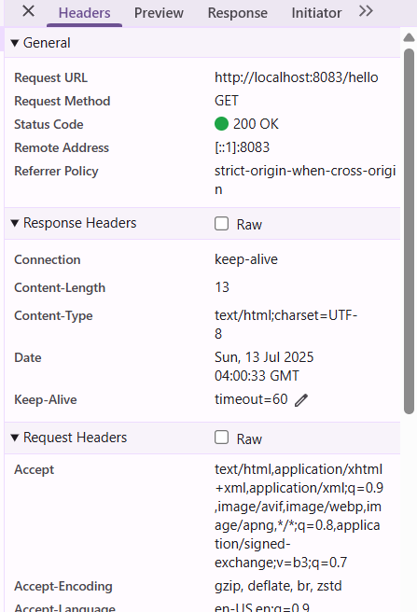

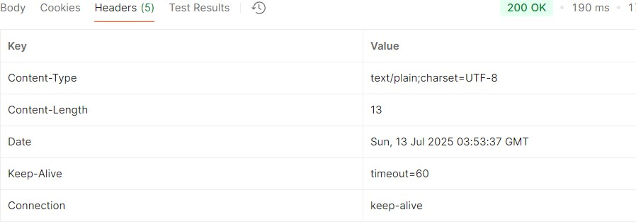

REST - Country Web Service
File name: SpringLearnApplication.java
package com.cognizant.springlearn;
import org.slf4j.Logger;
import org.slf4j.LoggerFactory;
import org.springframework.boot.SpringApplication;
import org.springframework.boot.autoconfigure.SpringBootApplication;
@SpringBootApplication
public class SpringLearnApplication {
private static final Logger LOGGER = LoggerFactory.getLogger(SpringLearnApplication.class);
public static void main(String[] args) { LOGGER.debug("START of main"); SpringApplication.run(SpringLearnApplication.class, args); LOGGER.debug("END of main");
}
}
File name: Country.java
package com.cognizant.springlearn;
public class Country {
private String code; private String name;
public Country() {
System.out.println("Inside Country Constructor.");
}
public String getCode() { return code;
}
public void setCode(String code) { System.out.println("Setting country code."); this.code = code;
}
public String getName() { return name;
}
public void setName(String name) { System.out.println("Setting country name."); this.name = name;
}
@Override
public String toString() {
return "Country [code=" + code + ", name=" + name + "]";}
}
File name:Country.xml
<?xml version="1.0" encoding="UTF-8"?>
<beans xmlns="http://www.springframework.org/schema/beans"
xmlns:xsi="http://www.w3.org/2001/XMLSchema-instance" xsi:schemaLocation="http://www.springframework.org/schema/beans
http://www.springframework.org/schema/beans/spring-beans.xsd">

<bean id="in" class="com.cognizant.springlearn.Country">
<property name="code" value="IN"/>
<property name="name" value="India"/>
</bean>

</beans>

File name:CountryController.java
package com.cognizant.springlearn.controller;
import com.cognizant.springlearn.Country;
import org.slf4j.Logger;
import org.slf4j.LoggerFactory;
import org.springframework.context.ApplicationContext;
import org.springframework.context.support.ClassPathXmlApplicationContext; import org.springframework.web.bind.annotation.RequestMapping;
import org.springframework.web.bind.annotation.RestController;
@RestController
public class CountryController {
private static final Logger LOGGER = LoggerFactory.getLogger(CountryController.class);
@RequestMapping("/country")
public Country getCountryIndia() {
LOGGER.info("START");
ApplicationContext context = new ClassPathXmlApplicationContext("country.xml");
Country country = (Country) context.getBean("in");
LOGGER.info("END");
return country;
}
}

OUTPUT:
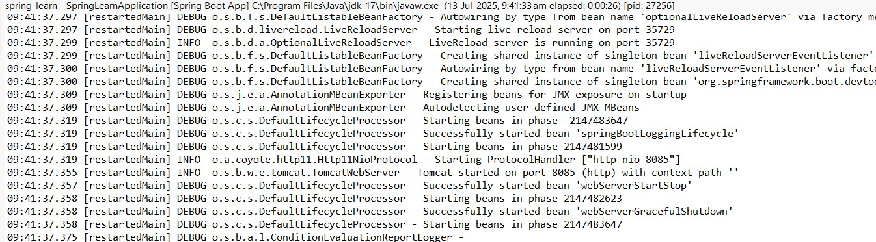
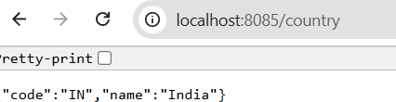

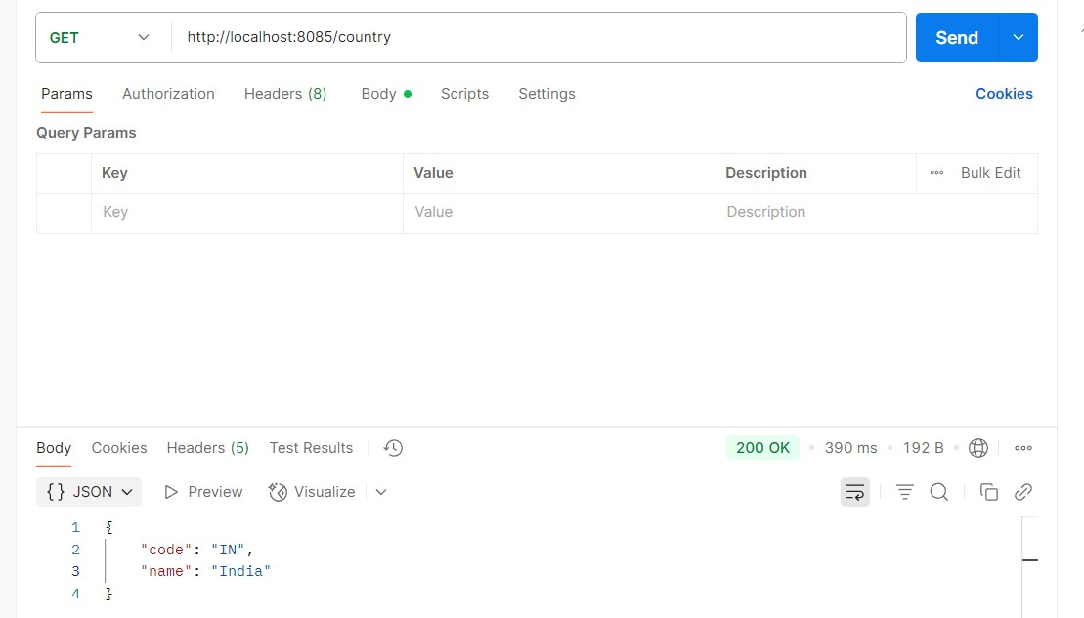

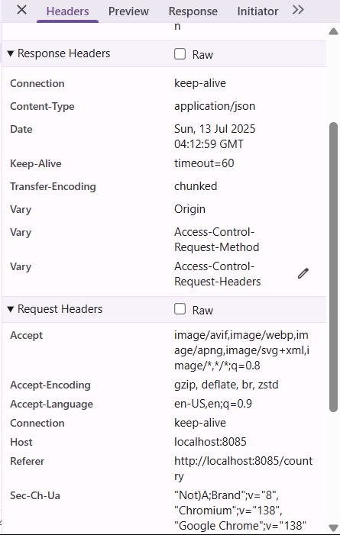
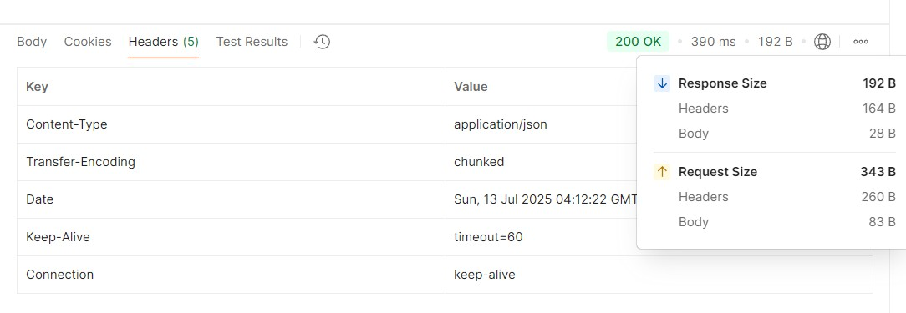

What happens in the controller method?
- The controller receives a GET request on /country.
- It logs START and loads Spring context from country.xml.
- Retrieves the bean with id in — a Country object representing India.
- Logs END and returns the bean as the HTTP response.
How is the bean converted into JSON?
  - Spring Boot uses Jackson library (auto-included via spring-boot-starter-web) to convert Java objects (POJOs) into JSON format.
  - The Country bean has getters, so Jackson serializes the object like this:
{ "code": "IN", "name": "India" }
  - This is done automatically due to @RestController, which combines @Controller + @ResponseBody.
REST - Get country based on country code File name:Country.java
package com.cognizant.springlearn;
public class Country {
private String code;
private String name;
public Country() {}
public String getCode() { return code;
}
public void setCode(String code) { this.code = code;
}
public String getName() { return name;
}
public void setName(String name) { this.name = name;
}
}

File name:Country.xml
<beans xmlns="http://www.springframework.org/schema/beans"
xmlns:xsi="http://www.w3.org/2001/XMLSchema-instance" xsi:schemaLocation="http://www.springframework.org/schema/beans
http://www.springframework.org/schema/beans/spring-beans.xsd">
<bean id="in" class="com.cognizant.springlearn.Country">
<property name="code" value="IN"/>
<property name="name" value="India"/>
</bean>
<bean id="us" class="com.cognizant.springlearn.Country">
<property name="code" value="US"/>
<property name="name" value="United States"/>
</bean>
<bean id="countryList" class="java.util.ArrayList">
<constructor-arg>
<list>
<ref bean="in"/>
<ref bean="us"/>
</list>
</constructor-arg>
</bean>
</beans>
File name:SpringLearnApplication.java
package com.cognizant.springlearn;
import org.slf4j.Logger;
import org.slf4j.LoggerFactory;
import org.springframework.boot.SpringApplication;
import org.springframework.boot.autoconfigure.SpringBootApplication;
@SpringBootApplication
public class SpringLearnApplication {
private static final Logger LOGGER = LoggerFactory.getLogger(SpringLearnApplication.class);
public static void main(String[] args) { LOGGER.debug("START of main"); SpringApplication.run(SpringLearnApplication.class, args); LOGGER.debug("END of main");
}
}

File name:CountryController.java
package com.cognizant.springlearn.controller;
import com.cognizant.springlearn.Country;
import com.cognizant.springlearn.service.CountryService;
import org.slf4j.Logger;
import org.slf4j.LoggerFactory;
import org.springframework.beans.factory.annotation.Autowired;
import org.springframework.web.bind.annotation.*;
@RestController
public class CountryController {
private static final Logger LOGGER = LoggerFactory.getLogger(CountryController.class);
@Autowired
private CountryService countryService;
@GetMapping("/countries/{code}")
public Country getCountry(@PathVariable String code) { LOGGER.info("START getCountry with code: {}", code); Country result = countryService.getCountry(code); LOGGER.info("END");
return result;

}
}
File name:CountryService.java
package com.cognizant.springlearn.service;
import com.cognizant.springlearn.Country;
import org.springframework.context.ApplicationContext;
import org.springframework.context.support.ClassPathXmlApplicationContext;
import org.springframework.stereotype.Service;
import java.util.List;
@Service
public class CountryService {
public Country getCountry(String code) {
ApplicationContext context = new ClassPathXmlApplicationContext("country.xml");
List<Country> countries = (List<Country>) context.getBean("countryList");
// Find country ignoring case return countries.stream()
.filter(c -> c.getCode().equalsIgnoreCase(code))
.findFirst()
.orElse(null); // or throw new CountryNotFoundException(code);
}
}

Output:
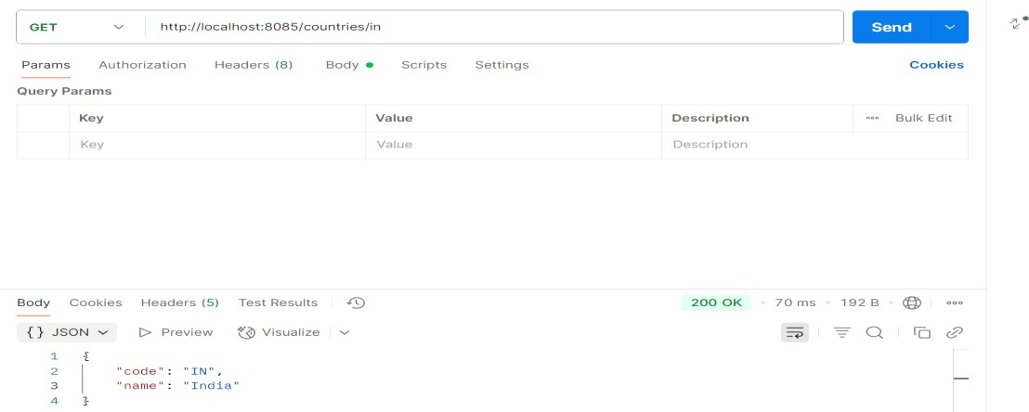
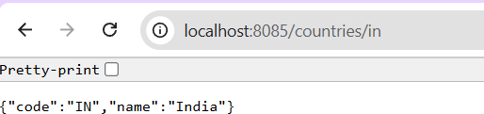
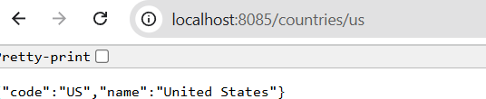
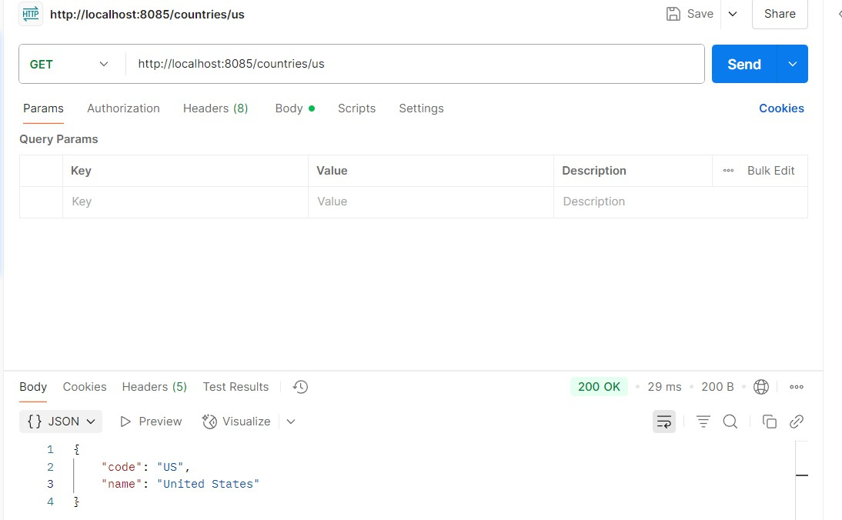

What happens in the controller?
- Controller gets the {code} from the URL via @PathVariable
- It calls countryService.getCountry(code)
- The service fetches the countryList from Spring XML
- It performs a case-insensitive match and returns the matching country
- How is the bean converted to JSON?
- Spring Boot uses Jackson (auto-configured with spring-boot-starter-web)
- Your Country class is a plain POJO with getters → automatically converted to JSON

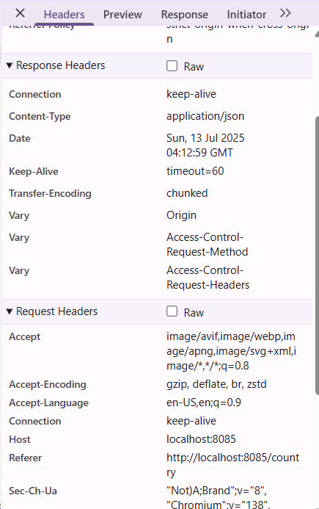

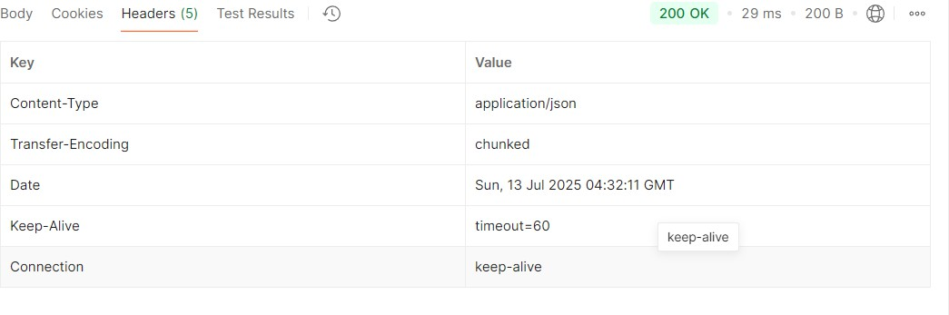

JWT-handson
Create authentication service that returns JWT
Create authentication controller and configure it in SecurityConfig
package com.cognizant.springlearn;
import org.springframework.boot.SpringApplication;
import org.springframework.boot.autoconfigure.SpringBootApplication;
@SpringBootApplication
public class SpringLearnApplication { public static void main(String[] args) {
SpringApplication.run(SpringLearnApplication.class, args);
}
}
package com.cognizant.springlearn.config;
import org.springframework.context.annotation.Bean;
import org.springframework.context.annotation.Configuration;
import org.springframework.security.config.annotation.web.builders.HttpSecurity;
import org.springframework.security.core.userdetails.User;
import org.springframework.security.core.userdetails.UserDetails;
import org.springframework.security.provisioning.InMemoryUserDetailsManager;
import org.springframework.security.web.SecurityFilterChain;
@Configuration
public class SecurityConfig {
@Bean
public InMemoryUserDetailsManager userDetailsService() {
UserDetails user = User.builder()
.username("user")
.password("{noop}pwd") // {noop} = No password encoding
.roles("USER")

.build();
return new InMemoryUserDetailsManager(user);
}
@Bean
public SecurityFilterChain filterChain(HttpSecurity http) throws Exception {
http.csrf(csrf -> csrf.disable())
.authorizeHttpRequests(auth -> auth
.requestMatchers("/authenticate").permitAll()
.anyRequest().authenticated()
)
.httpBasic();
return http.build();
}
}
package com.cognizant.springlearn.controller;
import org.springframework.beans.factory.annotation.Autowired;
import org.springframework.http.ResponseEntity;
import org.springframework.web.bind.annotation.*;
import com.cognizant.springlearn.util.JwtUtil;
import java.util.Base64;
import jakarta.servlet.http.HttpServletRequest;
@RestController
public class AuthenticationController {
@Autowired
private JwtUtil jwtUtil;

@GetMapping("/authenticate")
public ResponseEntity<?> authenticate(HttpServletRequest request) {
// Extract Authorization header
String authHeader = request.getHeader("Authorization");

if (authHeader == null || !authHeader.startsWith("Basic ")) {
return ResponseEntity.status(401).body("Missing or invalid Authorization header");
}

String base64Credentials = authHeader.substring("Basic ".length());
String credentials = new String(Base64.getDecoder().decode(base64Credentials)); String[] values = credentials.split(":", 2);
String username = values[0]; String password = values[1];
System.out.println("çPt'Inside authenticate()");

// For demo: accept only hardcoded user/pwd
if ("user".equals(username) && "pwd".equals(password)) { String token = jwtUtil.generateToken(username);
return ResponseEntity.ok().body("{\"token\":\"" + token + "\"}");
} else {
return ResponseEntity.status(403).body("Invalid credentials");
}
}
}
package com.cognizant.springlearn.util;
import io.jsonwebtoken.Jwts;
import io.jsonwebtoken.SignatureAlgorithm;
import io.jsonwebtoken.security.Keys;
import org.springframework.stereotype.Component;

importjavax.crypto.SecretKe; import java.util.Date;
@Component public class Jwt Util {
private static final SecretKey SECRET_KEY = Keys.secretKeyFor(SignatureAlgorithm.HS256); private static final long EXPIRATION_TIME = 1000 * 60 * 60; // 1 hour
public String generateToken(String username) { return Jwts.builder()
.setSubject(username)
.setIssuedAt(new Date())
.setExpiration(new Date(System.currentTimeMillis() + EXPIRATION_TIME))
.signWith(SECRET_KEY)
.compact();
}
}

OUTPUT
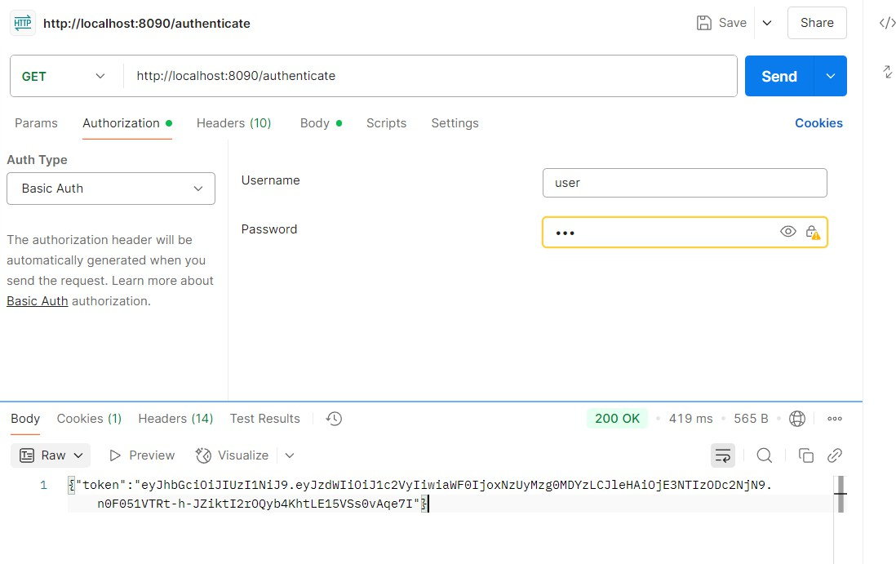

Read Authorization header and decode the username and password File name: AuthenticationController.java
package com.cognizant.springlearn.controller;
import java.util.Base64;
import org.slf4j.Logger;
import org.slf4j.LoggerFactory;
import org.springframework.http.HttpHeaders;
import org.springframework.http.ResponseEntity;
import org.springframework.security.authentication.AuthenticationManager;
import org.springframework.security.authentication.UsernamePasswordAuthenticationToken;
import org.springframework.security.core.Authentication;
import org.springframework.security.core.AuthenticationException;
import org.springframework.web.bind.annotation.*;
import com.cognizant.springlearn.util.JwtUtil;
@RestController
public class AuthenticationController {
private static final Logger LOGGER = LoggerFactory.getLogger(AuthenticationController.class);
private final AuthenticationManager authenticationManager; private final JwtUtil jwtUtil;
public AuthenticationController(AuthenticationManager authenticationManager, JwtUtil jwtUtil) { this.authenticationManager = authenticationManager;
this.jwtUtil = jwtUtil;
}
@GetMapping("/authenticate")
public ResponseEntity<?> authenticate(@RequestHeader(HttpHeaders.AUTHORIZATION) String authHeader) {
LOGGER.debug("START of authenticate()");

String username = getUser(authHeader);
LOGGER.debug("Extracted Username: {}", username);

try {
// The actual authentication step (optional since JWT is already returned) Authentication auth = new UsernamePasswordAuthenticationToken(username, "pwd"); authenticationManager.authenticate(auth);
} catch (AuthenticationException e) { LOGGER.error("Authentication failed for user: {}", username); return ResponseEntity.status(401).build();
}

String token = jwtUtil.generateToken(username);
LOGGER.debug("Generated JWT Token");
LOGGER.debug("END of authenticate()");
return ResponseEntity.ok().body("{\"token\":\"" + token + "\"}");
}
// This is the method to decode and extract username from Base64 encoded Authorization header
private String getUser(String authHeader) {
LOGGER.debug("START of getUser()");
if (authHeader == null || !authHeader.startsWith("Basic ")) { LOGGER.error("Invalid Authorization header: {}", authHeader); return null;
}
String encodedCredentials = authHeader.substring("Basic ".length()); byte[] decodedBytes = Base64.getDecoder().decode(encodedCredentials);
String decodedCredentials = new String(decodedBytes);
// will be user:pwd
LOGGER.debug("Decoded credentials: {}", decodedCredentials);
String username = decodedCredentials.split(":")[0];
LOGGER.debug("Extracted Username from Authorization header: {}", username);
LOGGER.debug("END of getUser()"); return username;
}
}
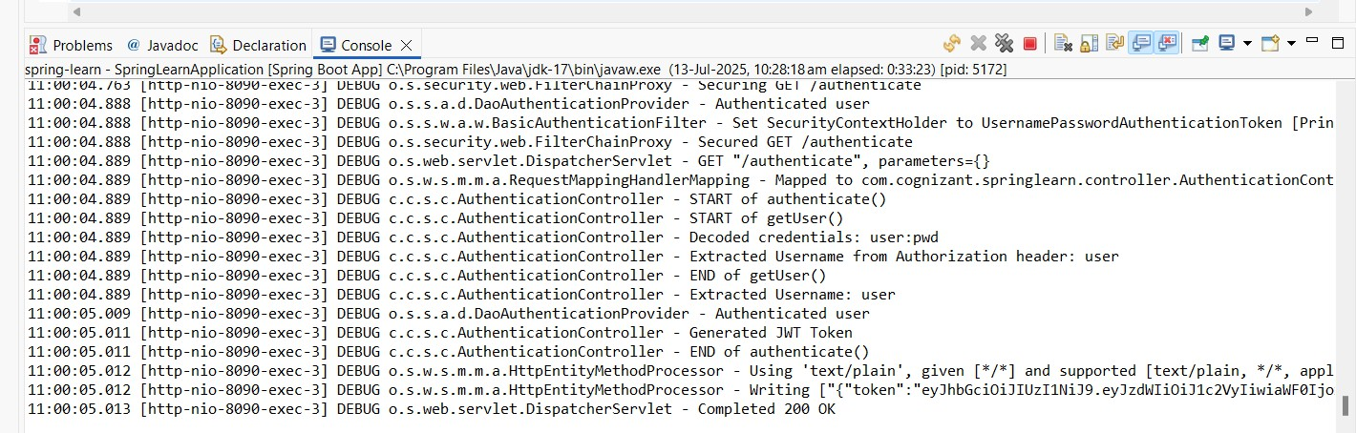
OUTPUT:

